Supplementary material

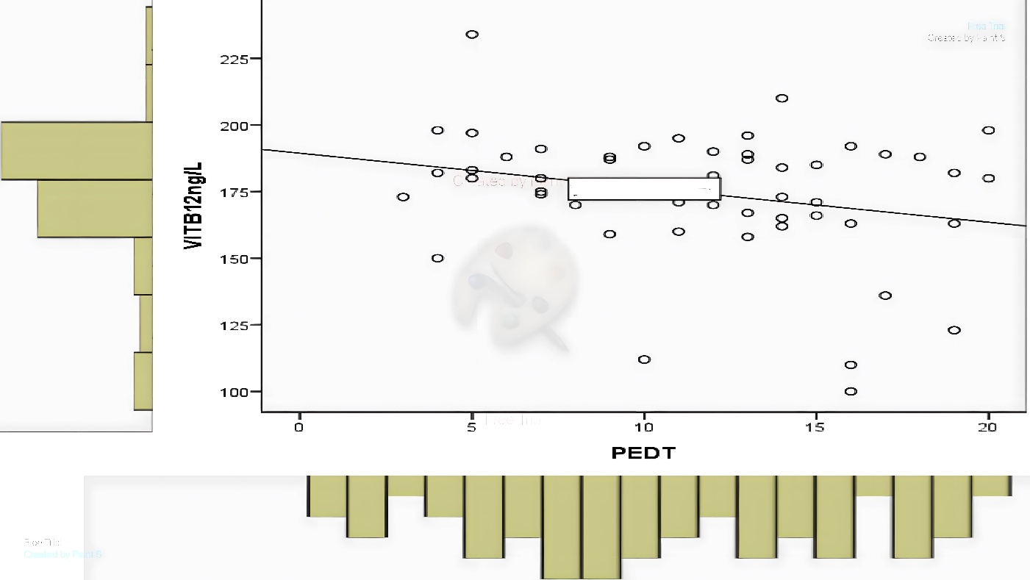
Supplementary Fig. 1. The distributions of baseline vitamin B12 levels and PEDT scores. PEDT: Premature ejaculation diagnostic tool.

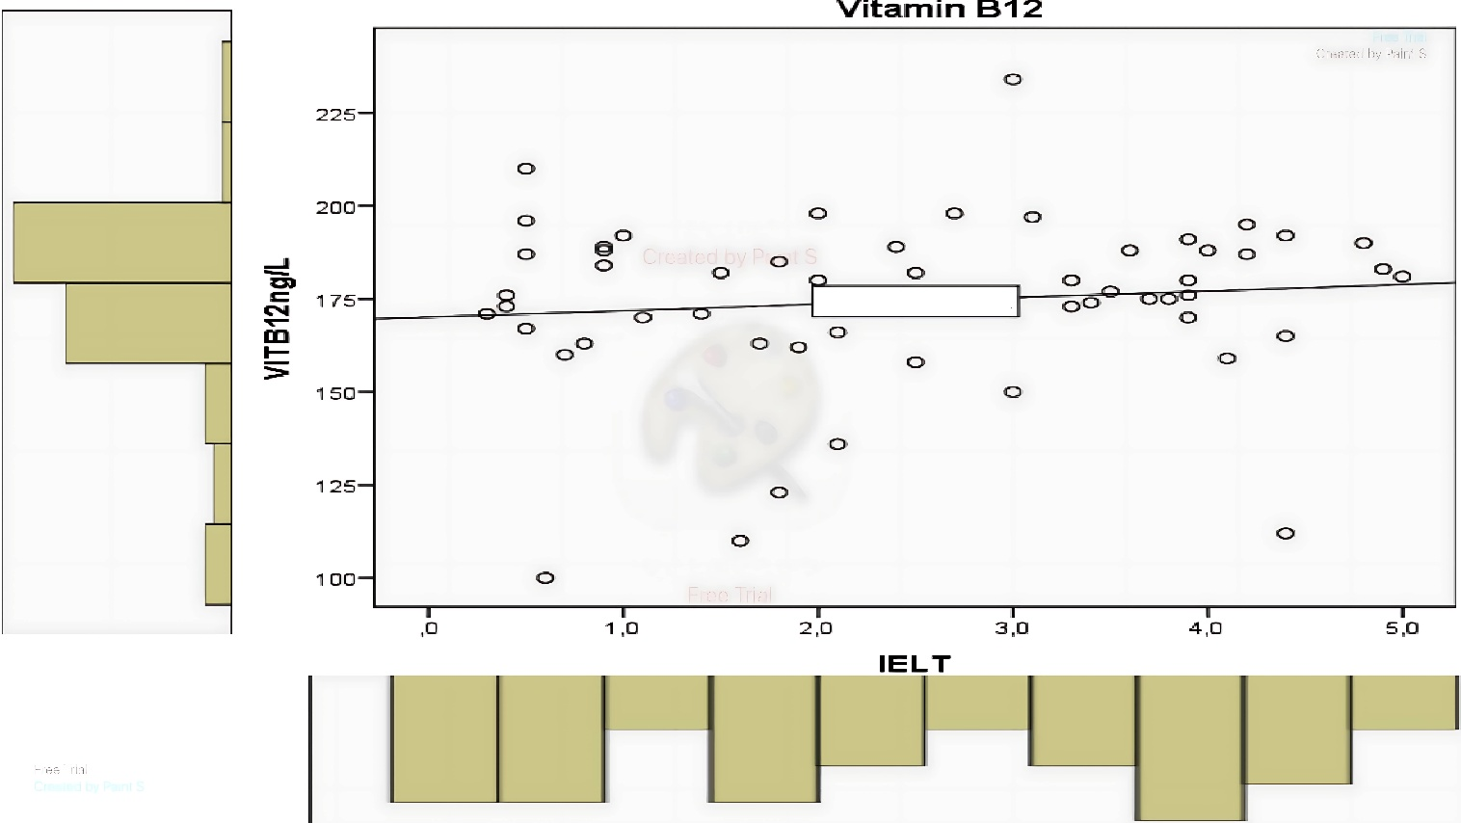
Supplementary Fig. 2. The distributions of baseline vitamin B12 levels and IELT scores. IELT: Intravaginal ejaculatory latency time.

